Call-on Congress FAQ
Who should attend?
Anyone who has been touched by colorectal cancer is welcome to attend Call-on Congress. – no experience necessary! Want to make it a family adventure? We offer a Junior Advocate program for children ages 6-17.

Registration for adults is $125 before January 1 and $150 after January 1. Junior Advocate registration is $50.

How much does Call-on Congress cost?
Costs associated with Call-on Congress include:
- Registration - $125 before January 1; $150 after January 1
- Lodging - $169/night
- Travel expenses – plane/train ticket or gas and mileage
- Meals – Meals will be provided except for dinner on 3/14

Where is Call-on Congress this year?
Call-on Congress 2017 will consist of two days of advocacy training at the Georgetown Hotel and Conference Center (3800 Reservoir Rd NW, Washington, DC 20007) and one day of meetings with members of Congress on Capitol Hill.

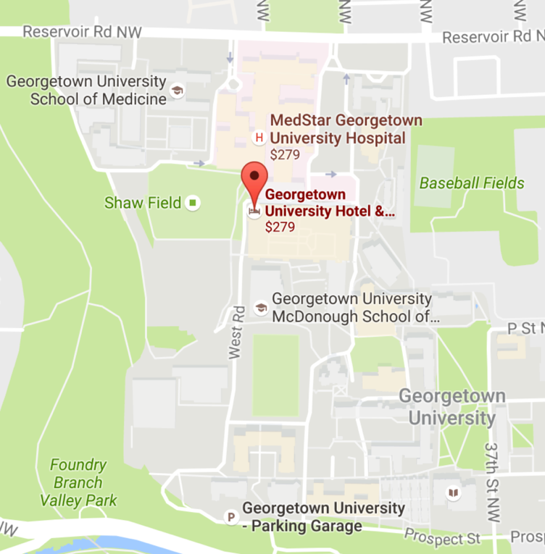

The Georgetown Hotel and Conference Center is located 8 miles from Capitol Hill and among the historic streets of Georgetown. We will provide transportation to your meetings with Congress on 3/15, and you will need to take a cab or an Uber back to the hotel after your meetings. Many attendees share cabs to cut costs.

Public transportation
The Georgetown Conference Center and Hotel does not have direct metro access. However, you can take the metro from DCA to the Rosslyn Station metro stop and take a shorter cab or Uber ride to the hotel. There is also a shuttle that runs from the Rosslyn metro station (blue, orange and silver lines) to the lower end of Georgetown University’s campus. From there, it's a 5-10 minute uphill walk to the conference center.

How do I reserve a hotel room and what is the nightly rate?
Fight CRC has a block of hotel rooms reserved at the Georgetown Hotel and Conference Center. Rooms can be reserved for $169 per night.

Click here to book your room.

Call-on Congress begins at 9am on Monday, 3/13 and concludes at 10pm on Wednesday, 3/15. Most attendees will reserve hotel rooms for 3/12-3/16.

Hotel rooms are limited; please reserve your room no later than February 10.

May I find a roommate?
You will be given the opportunity to indicate your preference during the registration process. If you would like to share a hotel room with another attendee, your contact information will be shared with others who are looking to split the cost of a room.

Which airport should I use?
We recommend flying into the Ronald Reagan National Airport (DCA) which is about a 20-minute cab or Uber ride to the hotel.

The Georgetown Conference Center and Hotel does not have direct metro access. However, you can take the metro from DCA to the Rosslyn Station metro stop and take a shorter cab or Uber ride to the hotel. There is also a shuttle that runs from the Rosslyn metro station (blue, orange and silver lines) to the lower end of Georgetown University’s campus. From there, it's a 5-10 minute uphill walk to the conference center.

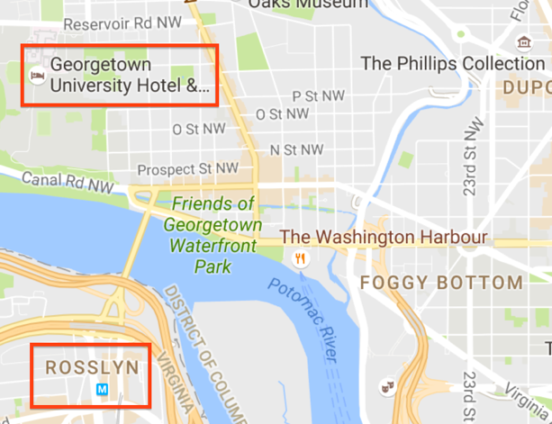

Is parking available on-site?
Parking is available directly under the hotel for $25 a night.

How do I register?
Call-on Congress attendees must register and pay the registration fee online. You can register here.

If you are a first-time attendee and have applied for a scholarship, please wait to register until after recipients are announced in early December. You can apply for a scholarship here.

